James Keller – GES408 – Lab 3 (Herbivory)

For this lab, we primarily want to think about whether leaf species determine the degree of herbivory.
- State an appropriate null and alternative hypothesis relating to this. (1 point)
  - H₀ : There is no difference in the mean amount of herbivory on White Clover and Japanese Honeysuckle
  - H_{A} : There is a difference in the mean amount of herbivory on White Clover and Japanese Honeysuckle.
- Complete the appropriate t-test within JASP. What was the p-value it gave you? We are going to stick with convention and use a significance level of p=0.05. Based on this, can we reject our null hypothesis? (1 point)
  - For this, we use the Independent Samples T-Test. From this we got a p value of 0.521. Based on this, we cannot reject our null hypothesis.
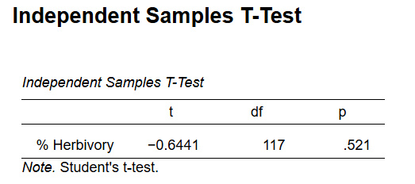
- Select the two tests in JASP that are appropriate for testing our assumptions of normality and equal variance. What are the results of those tests? (1 point)
  - The two tests we use are Shapiro-Wilk for normality and Levene’s for Equality of variances. The Shapiro-Wilk test yields a p-value less than 0.001 which suggests that our data deviates from normality. Levene’s test yields a p-value of 0.151 and this suggests that the variances of our two species are equal.
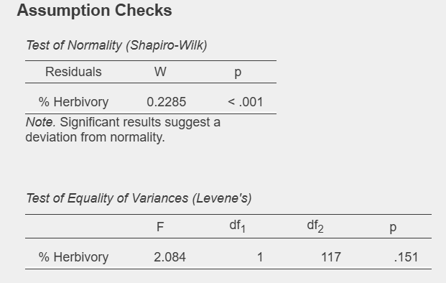
- If our data is not normal, we can try to transform it, or we can use a different type of test - Which one? Whether our data is normal or not, go ahead and carry out this test and describe the results. (1 point)
  - The next test we used was the Mann-Whitney U test. This test yielded a p-value less than 0.001 which suggests that the distributions of the two species are not the same.
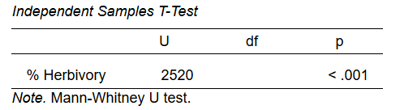
This test tests the null hypothesis that the distributions are the same, and the alternative hypothesis is that the distributions are not the same. Therefore, even if we reject the null, this doesn't necessarily imply anything about the central tendency of the data.
- To take a closer look, generate a histogram of the percent herbivory for each species (% herbivory on the x axis, count on the y axis). Briefly describe/compare the histograms. (2 points)
  - The histograms for both species are similar however it appears that the clover has a more normal distribution than Japanese Honeysuckle. 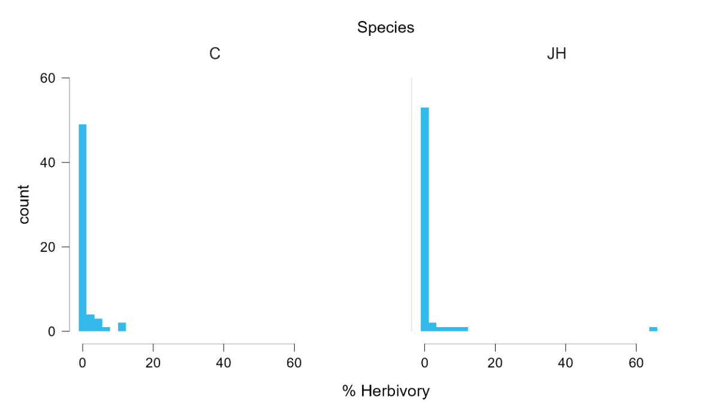
Whether or not our data produced results that are statistically significant, we may still be able to see a trend in the data.
- Generate a boxplot of the percent herbivory by species and briefly describe it. Additionally, provide the mean and standard deviation of the percent herbivory by species. (2 points)
  - The boxplot shows that clover has a higher percent herbivory on average than Japanese Honeysuckle. The means and standard deviations are below.

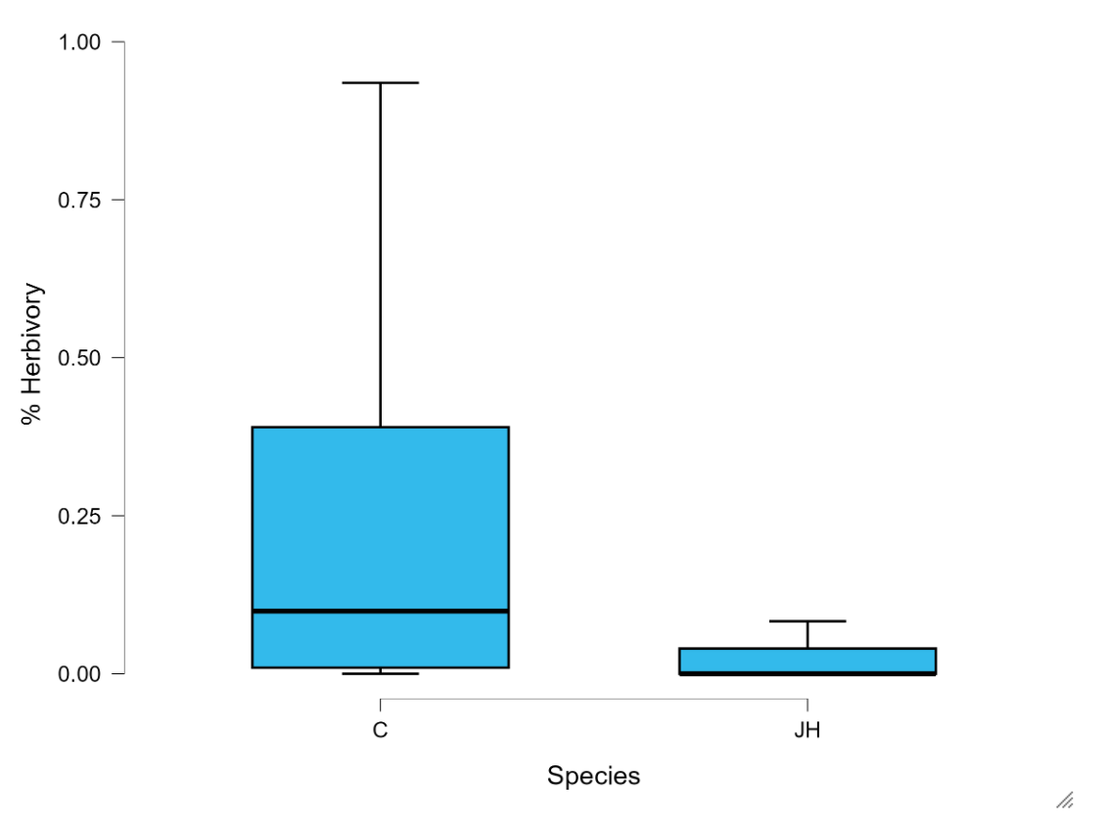
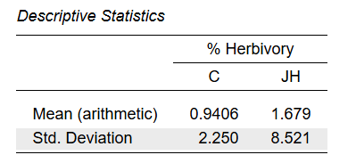
After our brief investigation, does leaf species appear to affect the pattern of herbivory in this case? Can you look up the characteristics of these plant species (or take into account your observations of the plants you sampled) and hypothesize one or two traits about either that might suggest an explanation for the pattern you observe? (2 points)
  - Leaf species does appear to affect the pattern or herbivory. One hypothesis is that more animals here have evolved to consume the native clover rather than the introduced honeysuckle. Another hypothesis is that clover is often much denser than the Japanese honeysuckle.
Last thing: Pick one of the other aspects of the leaves that we measured, and repeat these tests on it as an informal investigation. No need to provide any graphs, but do give a brief explanation of your results (3-4 sentences). (2 points)
  - I investigated the differences in leaf area between the two species. Both my Independent samples and Mann-Whitney T-Tests resulted in non-significant p-values which suggests that there is no difference in leaf area between the two species. The results of the Shapiro-Wilk and Levene’s test were also non-significant which suggests that the data is normally distributed for both species and that the variances were equal. The descriptive statistics also reveal similar means and variances between both species.

